# FIT3179 DATA VISUALISATION 2

Title: Celestial Visitors: A Visual Exploration of UFO Sightings

URL of Visualization: <https://2xuid.github.io/A2/>

URL of dataset: <https://www.kaggle.com/datasets/NUFORC/ufo-sightings>

## Introduction

Through the use of the Vega-Lite visualization library, we embark on a visual exploration of UFO sightings, offering a comprehensive lens into reported encounters worldwide. By leveraging the power of maps, diagrams, and interactive elements, we aim to unravel patterns and provide insights that transcend conventional understanding.

## Brief Description of the Domain (Why and Who):

This visualization delves into the realm of UFO sightings, offering a comprehensive exploration of reported encounters worldwide. The aim is to unravel patterns and trends within the dataset, providing a multifaceted lens for enthusiasts, researchers, and curious minds alike.

## Description of the Data (What):

The data used for this visualization is sourced from a CSV file containing information about UFO sightings. It includes details such as the date and time of the sighting, the city, state, country, UFO shape, duration, comments about sighting, and geographic coordinates. The data provides insights into when and where UFO sightings have occurred, the shapes of the reported objects, and the associated comments and descriptions. The dataset is relevant for anyone interested in exploring the patterns and trends in UFO sightings.

## Why and How

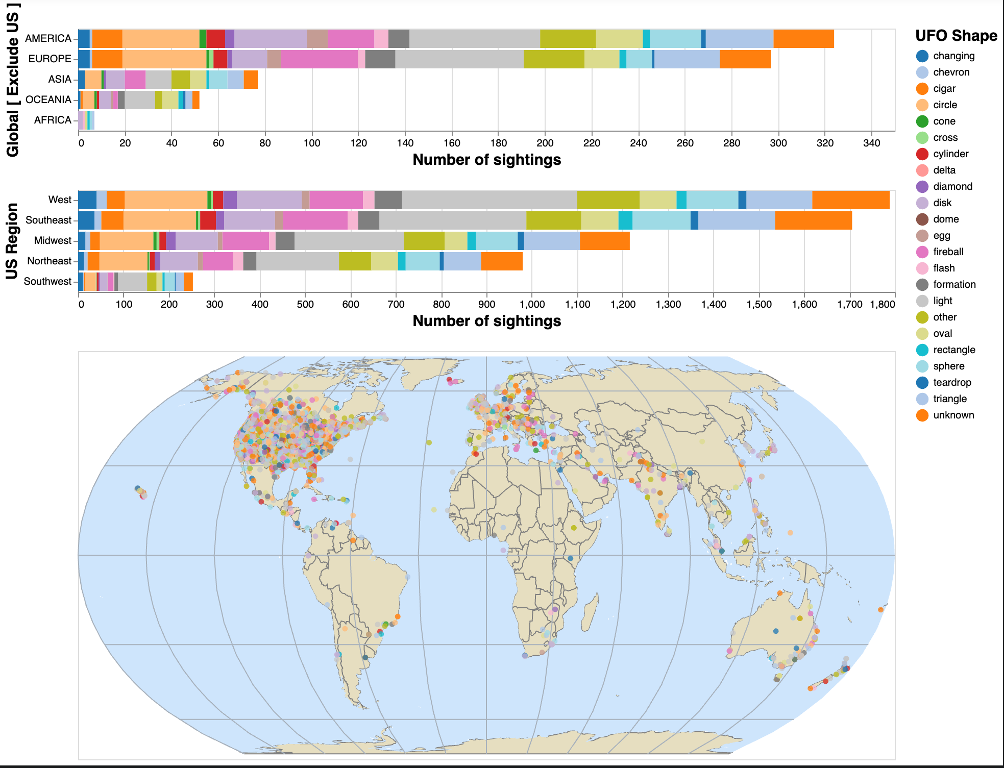

Choropleth Map: This powerful visualization tool provides an immediate snapshot of UFO sighting intensity in different countries. The colours indicate different shapes of UFO, and users can tell the number of UFO in the area by the density of the dots. Users can interact with the map by choosing the UFO shape to see the distribution of particular UFO shape. This dynamic feature allows for a detailed examination of sighting hotspots and regional variations. To help users in their exploration, tooltips are enabled for the map. Hovering over data points reveals additional information, including the city, state, and comments regarding the event.

Stacked bar charts: Stacked bar charts classify sightings by UFO shape and area. This map provides a clear overview of the distribution of sightings by shape and by country region. By interacting with legends, users can selectively view specific categories, enhancing their ability to discern trends. Stacked bar charts are also related to maps. If the user clicks on the bar chart, the map will show points in that area. This interaction can more clearly let the user know where in the map in the area they want to know.

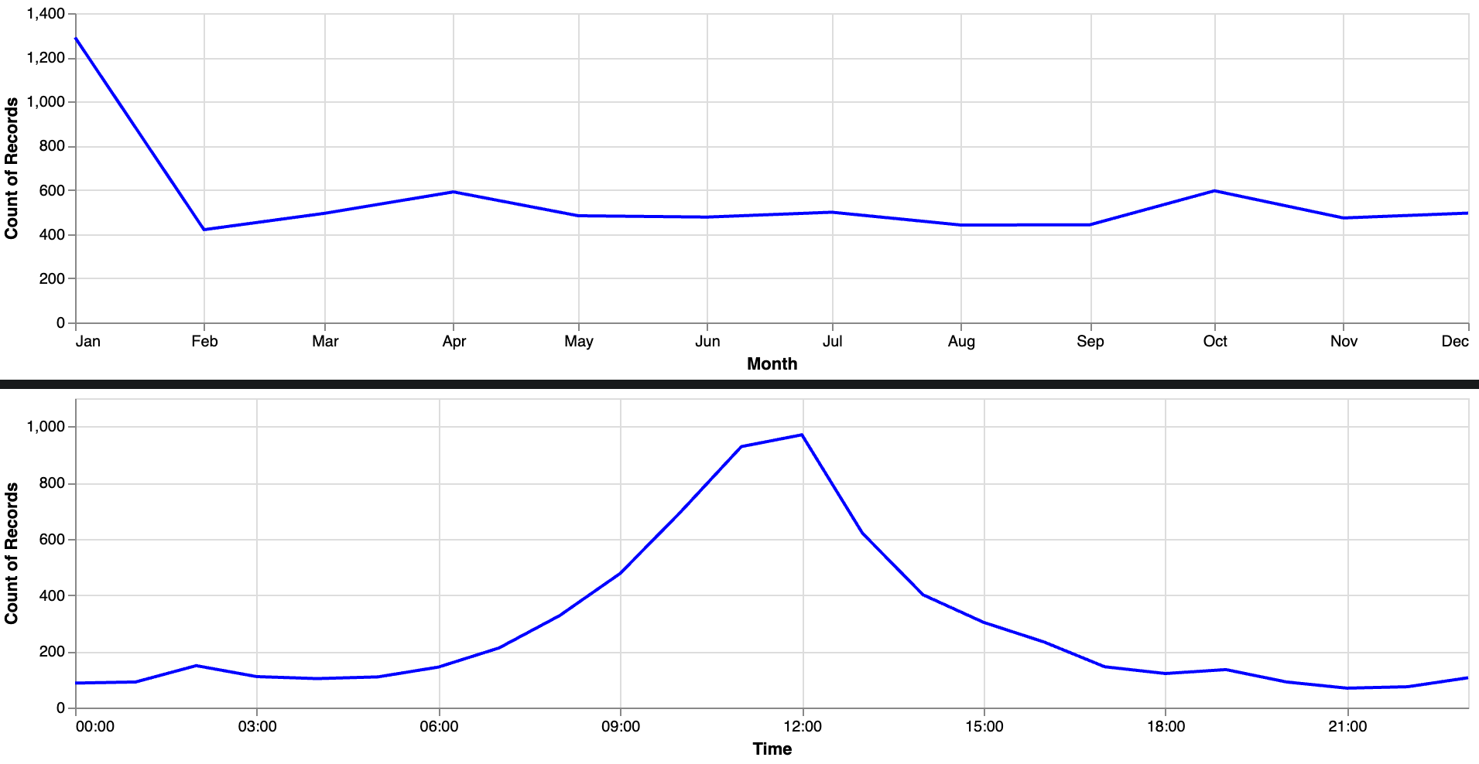

Time-based Trends: Line charts and rule charts reveal temporal trends in UFO sightings. By exploring the monthly and hourly variations, users can gain deeper insights into when sightings are most prevalent. This temporal analysis opens avenues for understanding potential patterns related to time of day and seasonality. To enhance user experience, tooltips are included in both charts. Users can hover over data points to view the precise count of sightings for each month or hour. This interactive feature allows users to dive deeper into the data and make more informed interpretations.

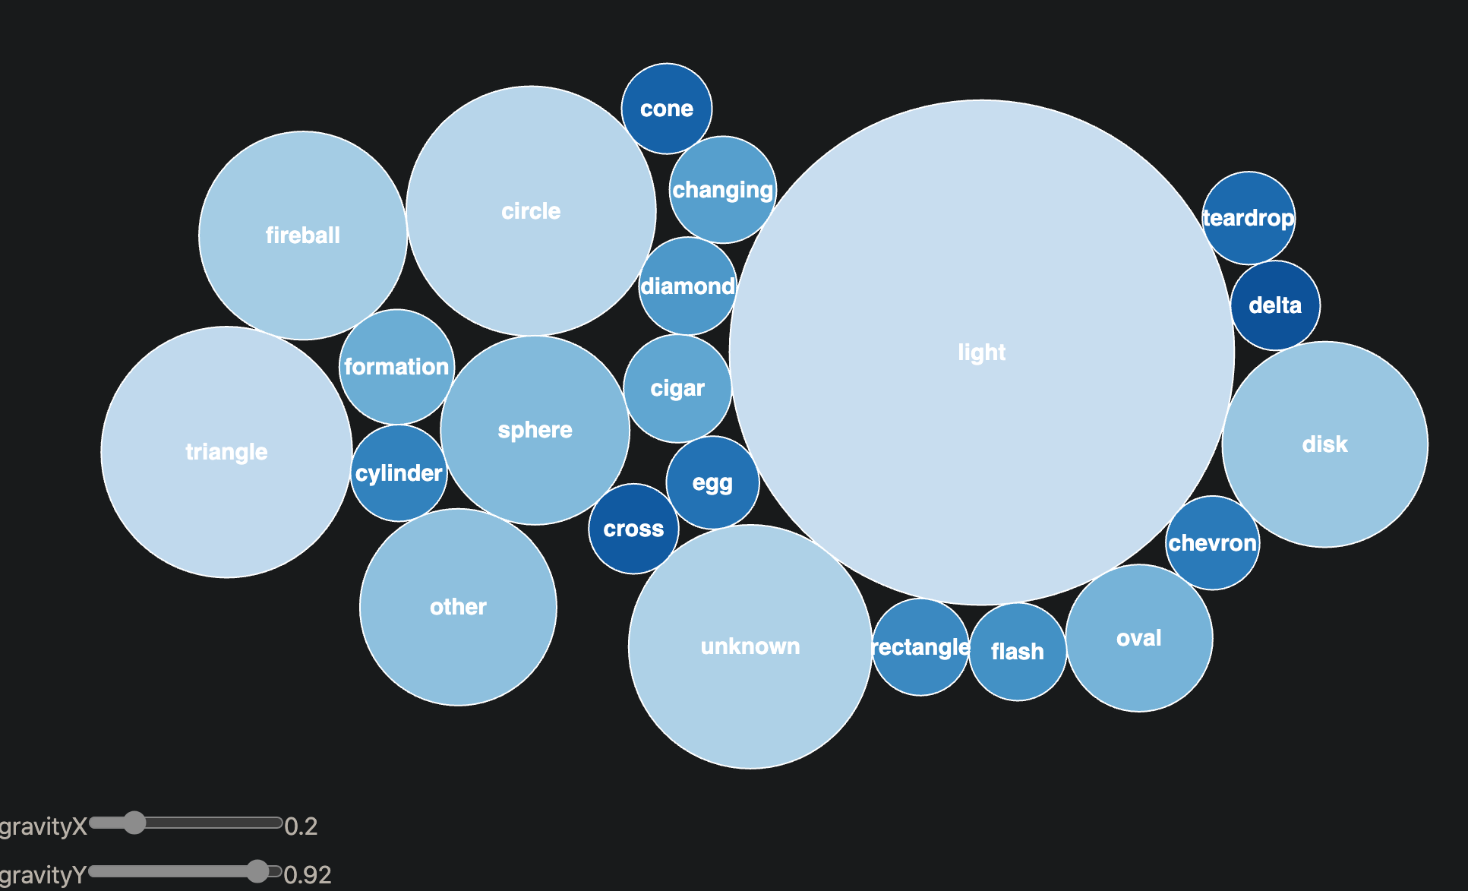

Bubble Chart: The dynamic bubble map shows the number of bubbles by their size, while allowing users to interact with parameters such as "gravityX" and "gravityY" to manipulate the distribution pattern of UFO shapes. This hands-on approach enables users to explore the data and potentially uncover hidden relationships.

## Design Rationale

Layout: The layout is carefully structured in columns and rows to ensure a seamless and intuitive navigation experience. The map takes centre stage, positioned at the top with the stacked bar charts, and followed by the bubble chart and temporal trend charts. This layout allows for a logical flow of information, guiding users through various aspects of UFO sightings.

Colour Palette: The selected colour palette balances visual appeal with clarity. Different colours represent the shape of the UFO, which is easy to distinguish the categories. The colours in the choropleth map are chosen to be closer to the real map and the sea is shown in the right blue. The visualization theme colour throughout is blue, which is gentler and more comfortable for the reader or user to visualize.

Figure-Ground: The visualization establishes a clear visual hierarchy to emphasize critical information such as UFO shape and region. This is achieved through judicious use of colour and strategic positioning of elements. The map acts as the primary graph, imparts essential context to the entire visualization. By grounding the data in this spatial context, users are better equipped to make meaningful interpretations and connections.

Typography: Readability is important, and to that end, legible words are used throughout the visualization. The font size is thoughtfully adjusted to optimize clarity for titles, content, axis labels, and annotations. This ensures that users can easily comprehend and navigate the information presented, enhancing their overall understanding and engagement.

Storytelling Annotations: To enhance the user's journey through the visualization, each chart is accompanied by detailed annotations. These annotations provide essential context to the data, highlighting key findings and trends, while also encouraging users to explore deeper. This guided narrative offers users a structured tour through the visualization, transforming it into a meaningful and enlightening experience. By weaving a narrative thread, the annotations empower users to derive insights and draw connections, ultimately enhancing their engagement with the data.

## Appendix

